Adani University,

Ahmedabad, Gujarat, India
A
Laboratory Report File
of
“Data Communication & Computer Networks”

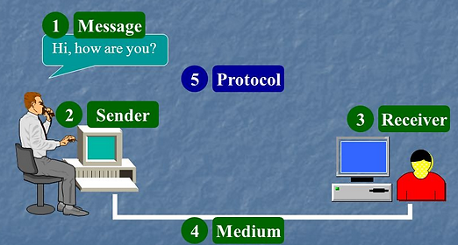

Submitted to: Submitted by:

Dr. Mani Shekhar Gupta Name: _______________________

FEST URN No.-______________________

Adani University B.E. (CSE, 4th sem., Batch: )

Department of Computer Science and Engineering

Adani University, Ahmedabad, Gujarat- 382421
Adani University, Ahmedabad, Gujarat

Name of Student __________________________________ URN No._____________________
Branch __________________________________ Section______________________
INDEX

S.  No. | Name of Experiment | Page no. | Date of Conduction | Signature | Remark
1
2
3
4
5
6
7
8
9
10

